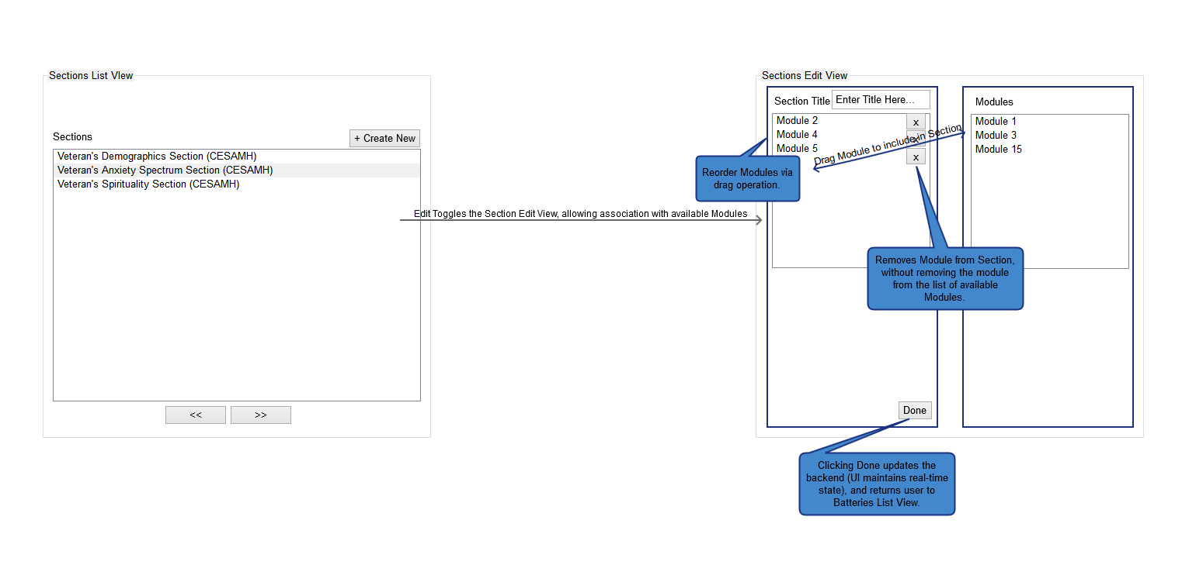

Figure 1: Section Editor Screen

* Initial view is a list of defined Sections viewable/selectable by the user. Selection brings up contextual button selection for entry into Edit flow. Selecting ‘Create New’ allows the user to create a new Section, composed of child Modules. Both Edit and Create New will navigate the user to the Edit view.
* In the Edit view, the user can define Section-specific properties (Name, at this time), and build out the Section by drag and drop of child Modules that will compose the defined Section at the top level.
* In the Edit flow, the user can reorder any dragged Module via a sortable drag operation. The result will change the navigational order of the Section’s Modules for users taking the Section when it is sent to the server.